Math 240 Exam I Fall 2011

Show all of your work in the exam booklet provided to you. Full credit will not be awarded for correct answers unless sufficient supporting work is presented.

1. (8 pts) For each matrix below indicate if it is in row-echelon form or reduced row-echelon form or neither.

a) 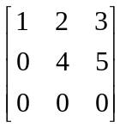 b) 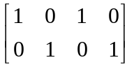 c) 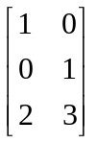 d) 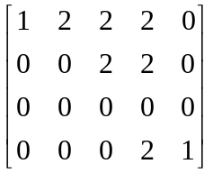

2. (6 pts) Consider the system of equations 3x + 9z=12
y+3z=6
x+y+6z=9

  - Write the system of equations as a matrix equation.
  - What matrix do you look at to solve the system of equations? (Do not solve.)

3. (4 pts) If u = 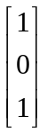and v =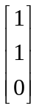 are solutions to the equation Ax = b. What can you say about the solution set of the system?

4. (6 pts) Write 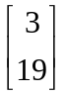 as a linear combination of the columns of 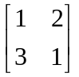

5. (10 pts) If A and B are m x n matrices and c is any scalar what is the strategy used to prove c(A+B) = cA + cB? Prove it.
6. (10 pts) Given that the matrix A is row equivalent to 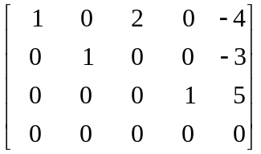
- Describe all the solutions of Ax = 0 in parametric vector form.
- Give a geometric description of this solution set.

7. (6 pts) Give an example of 2 x 2 matrices A and B such that A and B are both invertible but A + B is not invertible.

OVER →
8. (10 pts) Given that A and B are 3 x 5 matrices, u and v are column vectors in R⁵, and c and d are scalars determine if each given expression is a matrix, vector, scalar or undefined gibberish. No explanations are needed.

- AB^{T} b) cu + dv c) [A]_{ij} + [B]_{ij} d) uv e) A⁻¹+ B^{T}

9. (12 pts)
- Find all values of b for which the matrix 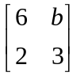 is invertible.
- Briefly describe the algorithm used in class to find the inverse of the matrix 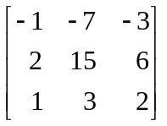 and then find it.

10. (9 pts) Use the matrix, A, given below to answer the questions and explain your answers.
A = 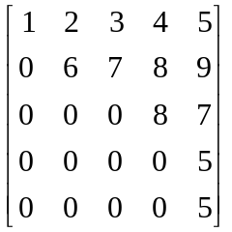

- Are the columns linearly independent?
- Is there a solution to the equation Ax = b for every vector b?
- Is the linear transformation defined by T(x) = Ax invertible?

11. (6 pts) Let T(x,y) = (x+y, x-y, 2x+3y). Find the standard matrix for T.

12. (10 pts) Let T be a linear transformation with standard matrix A. Which of the following statements are equivalent to saying T is one-to-one?
a) The columns of A are linearly independent.
b) There is a pivot in every row.
c) The system Ax = b is consistent for every vector b (assume b has the right # of entries)
d) The system Ax = b has at least one free variable.
e) The system Ax = 0 has a unique solution.

13. (3 pts) Carefully state the two defining rules that all linear transformations, T, must follow?

